FACE DETECTION SYSTEM

## A PROJECT REPORT

**for**

## Mini Project (KCA353)

## Session (2023-24)

**Submitted By**

**Pawan Kumar Sharma**

**(2200290140107)**

## Submitted in partial fulfillment of the Requirements for the Degree of

MASTER OF COMPUTER APPLICATIONS

**Under the Supervision of Dr. Amit Kr Goyal**

**(**ASSOCIATE PROFESSOR)



**Submitted to**

**DEPARTMENT OF COMPUTER APPLICATIONS**

## KIET Group of Institutions, Ghaziabad Uttar Pradesh 201206 (MAR 2024)

**DECLARATION**

I hereby declare that the work presented in report entitled “Face Detection System” was carried

out by me. I have not submitted the matter embodied in this report for the award of

any other degree or diploma of any other University of Institute. I have given due

credit to the original authors/sources for all the words, ideas, diagrams, graphics,

computer programs, that are not my original contribution. I have used quotation

marks to identify verbatim sentences and give credit to the original authors/sources.

I affirm that no portion of my work is plagiarized, and the experiments and results

reported in the report are not manipulated. In the event of a complaint of plagiarism

and the manipulation of the experiments and results, I shall be fully responsible

and answerable.

**Name: Pawan Kumar Sharma**

**Roll No.: 2200290140118**

**CERTIFICATE**

Certified that **PAWAN KUMAR SHARMA (University Roll No.-2200290140107)** has/ have carried out the project work having “**FACE DETECTION SYSTEM”** (**Mini Project-KCA353**) for **Master of Computer Application** from Dr. A.P.J. Abdul Kalam Technical University (AKTU) (formerly UPTU), Lucknow under my supervision. The project report embodies original work, and studies are carried out by the student himself/herself and the contents of the project report do not form the basis for the award of any other degree to the candidate or to anybody else from this or any other University/Institution.

**Date:**

**Pawan Kumar Sharma (2200290140107)**

This is to certify that the above statement made by the candidate is correct to the best of my knowledge.

**Dr. Amit Kr Goyal Dr. Arun Tripathi**

**Associate Professor Head**

**Department of Computer Applications Department of Computer Applications KIET Group of Institutions, Ghaziabad KIET Group of Institutions, Ghaziabad**

**FACE DETECTION SYSTEM**

PAWAN KUMAR SHARMA

**ABSTRACT**

The **FACE DETECTION SYSTEM** in this project employs OpenCV and Python to deliver real-time face detection capabilities. Beginning with image preprocessing to grayscale, the system utilizes the Haar Cascade classifier for efficient identification of facial patterns. It outlines detected faces with bounding boxes, providing a visual representation of the recognized regions. The system's key strengths lie in its accuracy, speed, and adaptability to varying lighting conditions. Future improvements may involve integrating deep learning models for enhanced precision and extending capabilities to support real-time video processing. This system finds applications in security, surveillance, biometric authentication, and multimedia processing, showcasing the practical implementation of face detection algorithms.

## ACKNOWLEDGEMENT

Success in life is never attained single-handedly. My deepest gratitude goes to my project supervisor, **Dr. Amit Kr Goyal** for their guidance, help and encouragement throughout my research work. Their enlightening ideas, comments, and suggestions.

Words are not enough to express my gratitude to **Dr. Arun Kumar Tripathi**, Professor and Head, Department of Computer Applications, for his insightful comments and administrative help at various occasions.

Fortunately, I have many understanding friends, who have helped me a lot in many critical conditions. Finally, my sincere thanks go to my family members and all those who have directly and indirectly provided me with moral support and other kinds of help. Without their support, completion of this work would not have been possible in time. They keep my life filled with enjoyment and happiness.

**Pawan Kumar Sharma**

**(2200290140107)**

## TABLE OF CONTENTS

### Chapter 1: INTRODUCTION PAGE NO.

* 1. Introduction 1
  2. Problem Statement 1
  3. Objectives 2
  4. Methodology 2
  5. Organization 8

1. Chapter 2: LITERATURE SURVEY
   1. Face Tracking 11
   2. Mechanisms of human facial recognition 11
   3. Eye Spacing Measurement for Facial Recognition 12
   4. A direct LDA algorithm for high-dimensional data 12
2. Chapter 3: SYSTEM DEVELOPMENT
   1. Recognizing the model by listing out the applications 13
   2. VIOLA JONES Algorithm 14
3. Chapter 4: PERFORMANCE ANALYSIS
   1. Training In OpenCV 20
   2. Training The Classifiers 20
   3. Functions 21
   4. Code 22
   5. Face Recognizer Class 27
   6. LBPH Class 28
   7. Predict 31
   8. Applications 35
4. Chapter 5: CONCLUSION
   1. Future Scope 36
   2. Limitations 36
   3. Conclusion 36

**LIST OF FIGURES**

|  |  |
| --- | --- |
| **Figure** | **Page No.** |
| Figure 1.1 | 6 |
| Figure 1.2 | 7 |
| Figure 1.3 | 7 |
| Figure 3.1 | 14 |
| Figure 3.2 | 15 |
| Figure 3.3 | 16 |
| Figure 3.4 | 17 |
| Figure 3.5 | 18 |
| Figure 3.6 | 19 |
| Figure 4.1 | 22 |
| Figure 4.2 | 23 |
| Figure 4.3 | 24 |
| Figure 4.4 | 25 |
| Figure 4.5 | 25 |
| Figure 4.6 | 26 |
| Figure 4.7 | 27 |
| Figure 4.8 | 28 |
| Figure 4.9 | 30 |
| Figure 4.10 | 30 |
| Figure 4.11 | 33 |
| Figure 4.12 | 34 |
| Figure 4.13 | 34 |
| Figure 4.14 | 35 |
| Figure 4.15 | 36 |

### LIST OF ABBREVIATIONS

|  |  |
| --- | --- |
| OpenCV | Open Computer Vision |
| NumPy | Numerical Python |
| PIL | Python imaging library |
| LDA | Linear Discriminant Analysis |
| LBPH | The Local Binary Pattern Histogram |
| XML | Extensible Markup Language |

**CHAPTER 1: INTRODUCTION**

#### INTRODUCTION

A face recognition system could also be a technology which is very capable of matching a personality's face from a digital image or a video frame which it has or use it as a reference to map and identify against an info of faces. Researchers’ area unit presently developing multiple ways throughout that face recognition systems work. the foremost advanced face recognition methodology, that is to boot used to manifest users through ID verification services, works by pinpointing and mensuration countenance from a given image.

While at first a kind of laptop application, face recognition systems have seen wider uses in recent times on smartphones and in alternative kinds of technol ogy, like artificial intelligence. as a result of computerized face recognition involves the measuring of a human's physiological characteristics face recognition systems area unit classified as bioscience. though the accuracy of face recognition systems as a biometric technology is a smaller amount than iris recognition and fingerprint recognition, it's wide adopted because of its contactless and non-invasive method. Facial recognition systems area unit deployed in advanced human -computer interaction, video police work and automatic compartmentalization of pictures.

We have a created a face recognition technology capable of identifying faces.

#### PROBLEM STATEMENT

“Face Detection System using Intel’s open-source Computer Vision Library (OpenCV) and Python dependency”

There are various scripts illustrated throughout the project that will have functionalities like detecting faces in static images, detecting faces in live feed using a webcam, capturing face images and storing them in the dataset, training of classifier for recognition and finally recognition of the trained faces.

All the scripts are written in python 3.6.5 and have been provided with documented code. This project lays out most of the useful tools and information for face detect ion

and face recognition and can be of importance to people exploring facial recognition with OpenCV.

The project shows implementation of various algorithms and recognition approaches which will be discussed on later in the project report.

Face Detection can be of importance in terms of security, organization, marketing, surveillance and robotics etc.

Face detection is able to very immensely improve surveillance efforts which can greatly help in tracking down of people with ill criminal record basically referring to criminals and terrorists who might be a vast threat to the security of the nation and the people collectively. The personal security is also greatly exacerbated since there is nothing for hackers to steal or change, such as passwords.

#### OBJECTIVES

This project is created so as to study the various means of recognizing faces with more accuracy and reducing the error rates while recognition. The ideal condition for any recognition project is to reduce the intra class variance of features and increase the inter class variance of features to be detected or recognized.

Facial Recognition software is “Capable of uniquely identifying or verifying a person by comparing and analyzing patterns based on the person’s facial contours. It is mostly used for security purposes”. Many other areas of use.

Different recognizer approaches are used for recognition of faces. They are:

* Eigen Faces
* Fisher Faces
* Local Binary Pattern Histograms

#### METHODOLOGY

The Project utilizes various libraries of Python such as

#### OpenCV

“OpenCV (Open-Source Computer Vision Library) is an open-source computer vision and machine learning software library”. The main purpose of this was to provide a common infrastructure for computer vision applications and it was also built specifically for such purposes not to mention it also accelerated the use of machine perception inside the business product. “Being a BSD-licensed product, OpenCV makes it straightforward for businesses to utilize and modify the code”.

In total we can say that The library has about 2500 optimized algorithms which is really insane, “These algorithms contain a comprehensive set which comprises of each classic and progressive laptop vision and machine learning algorithms. These algorithms area unit usually accustomed sight and acknowledge faces, determine objects, classify human actions in videos, track camera movements, track moving objects, extract 3D models of objects, manufacture 3D purpose clouds from s tereo cameras, sew pictures along to produce a high resolution image of a full scene, realize similar pictures from an image info, take away red eyes from pictures taken exploitation flash, follow eye movements, acknowledge scenery and establish markers to overlay it with increased reality, etc”. The amazing thing about this library is that it has quite about forty-seven thousand individuals of user community and calculable variety of downloads Olympian eighteen million. The library is utilized extensively in corporations, analysis teams and by governmental bodies.

Along with well-established corporations like “Google, Yahoo, Microsoft, Intel, IBM, Sony, Honda, Toyota” that use the library, there area unit several startups like “Applied Minds, VideoSurf, and Zeitera”, that create in depth use of OpenCV. OpenCV’s deployed wide array spans vary from sewing Streetview pictures along, police work intrusions in police work video in Israel, watching mine instrumentality in China, serving to robots navigate and devour objects at “Willow Garage, detection of natatorium drowning accidents in Europe, running interactive art in Espana and New York, checking runways for scrap in Turkey”, inspecting labels on product in factories around the world on to fast face detection in Japan.

#### NumPy

“The Python programming language earlier wasn't originally designed for numerical computing as we know it to be, however it also attracted the attention of the scientific and engineering community early”. “In 1995 the interest (SIG) matrix-sig was based with the aim of shaping associate array computing package; among its members was Python designer and supporter Guido van Rossum, WHO extended Python's syntax (in explicit the compartmentalization syntax) to make array computing easier”.

“An implementation of a matrix package was completed by Jim discoverer, then generalized[further rationalization required by Jim Hugunin and known as Numeric (also diversely observed because the "Numerical Python extensions" or "NumPy").Hugunin, a collegian at the Massachusetts Institute of Technology (MIT), joined the Corporation for National analysis Initiatives (CNRI) in 1997 to work on JPython,leaving Paul Dubois of Lawrence Livermore National Laboratory (LLNL) to need over as supporter. Other early contributors embrace David Ascher, Konrad Hinsen and Travis Oliphant”.

“A new package known as Numarray was written as a additional versatile replacement for Numeric. Like Numeric, it too is currently deprecated. Numarray had quicker operations for large arrays, however was slower than Numeric on tiny ones, thus for a time each packages were utilized in parallel for varied use cases. The last version of Numeric (v24.2) was discharged on St Martin's Day 2005, whereas the last version of numarray (v1.5.2) was discharged on twenty four August 2006”.

There was a want to urge Numeric into the Python customary library, however Guido van Rossum determined that the code wasn't reparable in its state then.

“In early 2005, NumPy developer Travis Oliphant needed to unify the community around one array package and ported Numarray's options to Numeric, cathartic the result as NumPy one.0 in 2006.This new project was a region of SciPy. To avoid putting in the large SciPy package simply to urge associate array object, this new package was separated and known as NumPy. Support for Python three was other in 2011 with NumPy version one.5.0”.

In 2011, PyPy started development on associate implementation of the NumPy API for PyPy. It is not nevertheless absolutely compatible with NumPy.

#### Pillow

The Python Imaging Library (PILLOW) or generally called as PIL is very useful for adding image processing capability to your Python interpreter which you have or have installed when working with Python.

The main use of this library is that this library has a wide array of extensive file format support which allows it to run and store different files in different formats, an efficient representation which is further boosted by very powerful image process ing ability. The important point is that the core image library is meant for faster access to data stored during a few basic pixel formats. All this enable it to be a very commanding and powerful tool for image processing general, which is probably also the reason why it is used so heavily.

Let’s see a couple of possible things in which we can use this library.

Image Archive-The “Python Imaging Library” is right for image archival and execution applications. you'll use the library to make thumbnails, convert between file formats, print images, etc.

From the information available to us currently about the current version is that it identifies and reads an outsized number of file formats. Write support is intentionally restricted to the foremost commonly used interchange and presentation formats.

“Image Display-The current release includes Tk Photo Image and Bitmap Image interfaces, also as a Windows DIB interface which will be used with PythonWin and other Windows-based toolkits. Many other GUI toolkits accompany some quite PIL support”. “For a purpose such as debugging there are a lot of functions like the show() method which saves a picture to disk, and callsit an external display utility.

Image Processing-The library contains basic image processing functionality, including point operations, filtering with a group of built-in convolution kernels, and color space conversions”. Basically in short the “Python Imaging library” is a free additional open source library which you have to install first by using the command such as pip so that you can use it to run various python functions in the module. It is important to note and keep in mind that all of these functions only work once you import this library and cannot be used if the library isn’t imported or called upon. Henceforth why is it recommended to install this library beforehand in order to properly use it.In regards to the main function of this library is to add functionality in opening, manipulating and storing of different file format images which can later be used to perform operations on accordingly to the needs of the programmer using the library.

#### FACE RECOGNITION

The “Face recognition” library in python is a library which helps in recognizing and manipulating the faces by using the programming language python or from the command line with the simplest face recognition library after importing the module and accessing the required functions. The “Face recognition” library was built using dlib’s “state-of-the-art face recognition” and was further enhanced and built with deep learning. The model has an accuracy of 99.38%.It is used to find faces in pictures

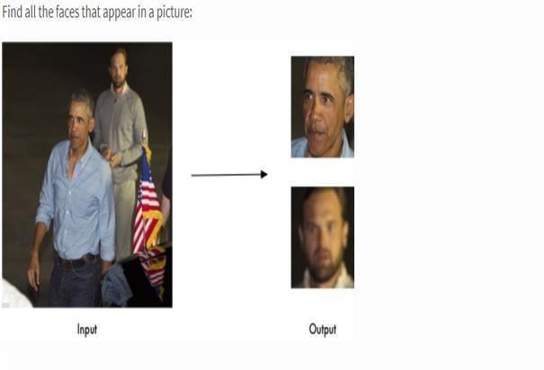

Figure 1.1: Finding all the faces in the picture

Find and according look for facial features in the pictures

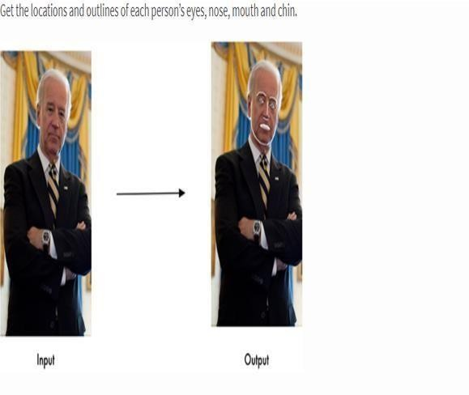

Figure 1.2:Getting the locations

#### Organization

Biometrics in simple terms basically refers to evaluating and measuring your Fingerprints, face features or any such human parameters that help to identify an individual. The study of Biometrics is very much important considering how bleak the security as a whole has become. Note that identification is only possible since each and every person has unique and distinct features which make it easier to identify individuals.

Keep in mind that the biometric feature which is being used or are being used must be available in the database for all individuals in the community before the feature or those features can be used for authentication. This is called enrolment.

Authentication can be in one of the following forms

* Identification: This basically refers to matching an individual’s features against all the records to check whether his/her or simply put that if or not the record is there in the database or not
* Verification: “To check whether the person is who he/she is claiming to be”. In other words to check whether their claim of identity is true or not. In this case the features of the person is matched only with the features of the person they claim themselves to be.

Types of Biometrics:

There are two broad categories of biometrics:

1. Physiological Biometrics
2. Behavioral Biometrics Physiological Biometrics:

“As the name sounds out to be in this the physical traits of a person are measured greatly for identification and verification in this type of biometrics. The trait should be chosen such that it is unique among the general population, and no matter what is resistant to changes due to illness, aging, injury, etc.”.

**Physiological Biometric Techniques:**

* **Fingerprint**: Fingerprints are one of the main methods to uniquely identify an individual. They are also regarded as one of the best methods for this sole purpose and many systems utilize this sort of recognition method. They are unique for every individual and can also be measured in several different ways. Minutiae -based measurement uses graphs which are there to match the ridges contained whereas image- based measurement finds similarities or the similar patterns in between the fingertips image and fingerprint images which are present or which have been uploaded in the database for the purpose of matching and uniquely identifying the identity of the person concerned. The security level is very high and used both for identification and verification. However, due to old age or diseases/injury, fingerprint may get altered. Common usage: in mobiles for verification, in offices for identification.
* **Facial Recognition**: This basically refers to the set of the features of the face like distance between the nose and the mouth or say the distance between the ears, length of face, skin color, are used for verification and identification in this regard. However, there can be certain complications arising due to the complexity in aging, disease, wearing sunglasses or any sort of face that disrupts to recognize those featrues and indirectly hampering the outcome greatly by playing a role in the low accuracy of the results.
* **Iris and Retina:** Not only just fingerprints the patterns found in say the iris and retina are also unique metrics which can be used to deicde or identify the concerned Devices to analyse retina are expensive and hence it is less common. Diseases like cataract may hinder the pattern recognition of the iris and may cause discrepancies to occur
* **Voice Recognition**: The third kind of recognition that can be used is the voice recognition which is also very helpful. The pitch, voice modulation, and tone, among other things are taken into consideration and are taken in the dataset . Regarding the security of the system,it isnt necessarily a great choice in that regard since two different people can have same voice and henceforth the model will have to deal with a lot of problems and wich is why it isnt all that great and isnt used mostly in

recognition. The accuracy can be hindered due to the presence of noise, or due to aging or illness.

* **DNA**: DNA might be the most unique kind of authentication, since it is the most trusted metric for uniquely identifying an individual. Thus, security is high and can be used for both identification and verification

**Behavioral Biometrics:**

In this the traits are generally measured, which relate to the behavior patterns of the individual and which can be a great source of authentication

* Signature: “Signature might just be one of the most used metrics for authentication. They are used to verify checks by matching the signature of the check against the signature present in the database. Signature tablets and special pens are used to compare the signatures”. Duration required to write the signature can also be used to increase accuracy. Signatures are mostly used for verification.
* Keystroke Dynamics: This technique measures the behavior of a person when typing on a keyboard. Some of the characteristics take into account are:

1. Typing speed-refers to how fast the person can type and matches that
2. Frequency of errors-what is the frequency of the errors committed
3. Duration of key depressions

### CHAPTER 2: LITERATURE SURVEY

### Face Tracking

Face tracking refers to identifying the features which are then used to detect a Face In this case the example method includes the receiving or we can say that it gets the first image and the second images of a face of a user who is being taken into consideration, where one or both of the images which were used to sort of look for a match have been granted a match by the facial recognition system which also proofs the correct working of the system. “The technique includes taking out a second sub- image coming from the second image, where the second sub-image includes a representation of the at least one corresponding facial landmark, detecting a facial gesture by determining whether a sufficient difference exists between the second sub - image and first sub-image to indicate the facial gesture, and determining, based on detecting the facial gesture, whether to deny authentication to the user with respect to accessing functionalities controlled by the computing” [1]

#### Mechanisms of human facial Recognition

Basically, what we see in this paper is that it presents an extension and a new way of perception of the author's theory for human visual information processing, which The method includes extracting a second sub-image from the second image, where the second sub-image includes a representation of the at least one corresponding facial landmark. “In turn detecting a facial gesture by determining whether a sufficient difference exists between the second sub-image and first sub-image to indicate the facial gesture, and determining, based on detecting the facial gesture, whether to deny authentication to the user with respect to the human recognition system and same was applied”. Several indispensable techniques are implicated: encoding of visible photographs into neural patterns, detection of easy facial features, measurement standardization, discount of the neural patterns in dimensionality [2].

“The logical (computational) role suggested for the primary visual cortex has several components: size standardization, size reduction, and object extraction”. “The result of processing by the primary visual cortex, it is suggested, is a neural encoding of the

visual pattern at a size suitable for storage. “(In this context, object extraction is the isolation of regions in the visual field having the same color, texture, or spatial extent.)” It is shown in detail how the topology of the mapping from retina to cortex, the connections between retina, lateral geniculate bodies and primary visual cortex, and the local structure of the cortex itself may combine to encode the visual patterns. Aspects of this theory are illustrated graphically with human faces as the primary stimulus. However, the theory is not limited to facial recognition but pertains to Gestalt recognition of any class of familiar objects or scenes [2].

#### Eye Spacing Measurement for Facial Recognition

Few procedures to computerized facial consciousness have employed geometric size of attribute points of a human face. Eye spacing dimension has been recognized as an essential step in reaching this goal. Measurement of spacing has been made by means of software of the Hough radically change method to discover the occasion of a round form and of an ellipsoidal form which approximate the perimeter of the iris and each the perimeter of the sclera and the form of the place under the eyebrows respectively. Both gradient magnitude and gradient direction were used to handle the noise contaminating the feature space. “Results of this application indicate that measurement of the spacing by detection of the iris is the most accurate of these three methods with measurement by detection of the position of the eyebrows the least accurate. However, measurement by detection of the eyebrows' position is the least constrained method. Application of these strategies has led to size of a attribute function of the human face with adequate accuracy to advantage later inclusion in a full bundle for computerized facial consciousness”. [3].

**CHAPTER 3: SYSTEM DEVELOPMENT**

#### Recognizing the model by listing out the applications

Face detection is a computer technology being used in a variety of applications that ident ifies human faces in digital images. Face detection also refers to the psychological proce ss by which humans locate and attend to faces in a visual scene.Face detection can be reg arded as a specific case of objectclass detection. In objectclass detection, the task is to fi nd the locations and sizes of all objects in an image that belong to a given class. Example s include upper torsos, pedestrians, and cars. Facedetection algorithms focus on the dete ction of frontal human faces. It is analogous to image detection in which the image of a p erson is matched bit by bit. Image matches with the image stores in database. Any facial f eature changes in the database will invalidate the matching process.Face Detection has f ound its application in various fields such as:

* Facial motion capture: Facial motion capture is the process of electronically converting the movements of a person's face into a digital database using cameras or laser scanners. This database may then be used to produce CG (computer graphics) computer animation for movies, games, or real-time avatars. Because the motion of CG characters is derived from the movements of real people, it results in more realistic and nuanced computer character animation than if the animation were created manually.
* Facial recognition: Facial recognition system is a technology capable of identifying or verifying a person from a digital image or a video frame from a video source. There are m ultiple methods in which facial recognition systems work, but in general, they work by c omparing selected facial features from given image with faces within a database. It is als o described as a Biometric Artificial Intelligence based application that can uniquely ide ntify a person by analysing patterns based on the person's facial textures and shape. It is a lso used in video surveillance, human computer interface and image database manageme nt.
* Photography: Some recent digital cameras use face detection for autofocus. Face detect ion is also useful for selecting regions of interest in photo slideshows that use a pan-and- scale Ken Burns effect.
* Marketing: Face detection is gaining the interest of marketers. A webcam can be integra ted into a television and detect any face that walks by.

#### VIOLA-JONES ALGORITHM

The Viola-

Jones algorithm is a widely used mechanism for object detection. The main property of t his algorithm is that training is slow, but detection is fast. This algorithm uses Haar basis feature filters, so it does not use multiplications.

The efficiency of the Viola-

Jones algorithm can be significantly increased by first generating the integral image.

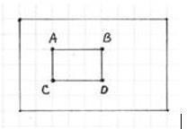

Figure 3.1: Recatangle used

Detection happens inside a detection window. A minimum and maximum window size i s chosen, and for each size a sliding step size is chosen. Then the detection window is mo ved across the image as follows:

1. Set the minimum window size, and sliding step corresponding to that size.
2. For the chosen window size, slide the window vertically and horizontally with the sam e step. At each step, a set of N face recognition filters is applied. If one filter gives a posit ive answer, the face is detected in the current widow.
3. If the size of the window is the maximum size stop the procedure. Otherwise increase the size of the window and corresponding sliding step to the next chosen size and go to the step 2.Each face recognition filter (from the set of N filters) contains a set of cascade- connected classifiers. Each classifier looks at a rectangular subset of the detection wind ow and determines if it looks like a face. If it does, the next classifier is applied. If all classifiers give a positive answer, the filter gives a positive answer and the face is recognized

. Otherwise the next filter in the set of N filters is run.

Each classifier is composed of Haar feature extractors (weak classifiers). Each Haar feaure is the weighted sum of 2D integrals of small rectangular areas attached to each other. The weights may take values ±1. Fig.2 shows examples of Haar features relative to the enclosing detection window. Gray areas have a positive weight and white areas have a negative weight. Haar feature extractors are scaled with respect to the detection window size.

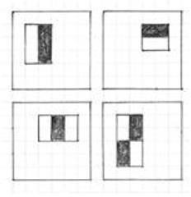

Figure 3.2: Classifiers

**Object Detection using Haar feature-**

based cascade classifiers is an effective object detection method proposed by Paul Viola and Michael Jones in their paper, "Rapid Object Detection is using a Boosted Cascade of Simple Features" in 2001. It is a machine learning based approach where a cascade function is trained from a lot of positive and negative images. It is then used to detect objects in other images. Here we will work with face detection. Initially, the algorithm needs a lot o f positive images (images of faces) and negative images (images without faces) to train the classifier. Then we need to extract features from it. For this, Haar features shown in th e below image are used. They are just like our convolutional kernel. Each feature is a sin gle value obtained by subtracting sum of pixels under the white rectangle from sum of pixels under the black rectangle.

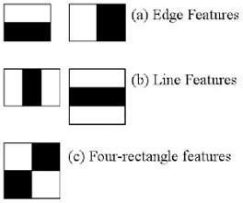

Figure 3.3

Now, all possible sizes and locations of each kernel are used to calculate lots of features. (Just imagine how much computation it needs? Even a 24x24 window results over 16000 0 features). For each feature calculation, we need to find the sum of the pixels under whit e and black rectangles. To solve this, they introduced the integral image. However large your image, it reduces the calculations for a given pixel to an operation involving just four pixels. Nice, isn't it? It makes things super-fast.

But among all these features we calculated, most of them are irrelevant. For example, consider the image below. The top row shows two good features. The first feature selected seems to focus on the property that the

region of the eyes is often darker than the region of the nose and cheeks. The second feature selected relies on the property that the eyes are darker than the bridge of the nose. But the same windows applied to cheeks or any other place is irrelevant. So how do we select the best features out of 160000+ features? It is achieved by Adaboost.

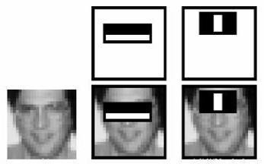

Figure 3.4

The final classifier is a weighted sum of these weak classifiers. It is called weak because it alone can't classify the image, but together with others forms a strong classifier. The pa per says even 200 features provide detection with 95% accuracy. Their final setup had ar ound 6000 features. (Imagine a reduction from 160000+ features to 6000 features. That is a big gain).So now you take an image. Take each 24x24 window. Apply 6000 features to it. Check if it is face or not. Wow.. Isn't it a little inefficient and time consuming? Yes, i t is. The authors have a good solution for that. In an image, most of the image is nonface re gion. So it is a better idea to have a simple method to check if a window is not a face region. If it is not, discard it in a single shot, and don't process it again. Instead, focus on regio ns where there can be a face. This way, we spend more time checking possible face regions. For this they introduced the concept of Cascade of Classifiers. Instead of applying all 6000 features on a window, the features are grouped into different stages of classifiers an d applied one-by-

one. (Normally the first few stages will contain very many fewer features). If a window f ails the first stage, discard it. We don't consider the remaining features on it. If it passes, apply the second stage of features and continue the process. The window which passes al l stages is a face region. How is that plan! The authors' detector had 6000+ features with 3 8 stages with 1, 10, 25, 25 and 50 features in the first five stages. (The two features in the above image are actually obtained as the best two features from Adaboost).

**LIVE CAM FEED:**

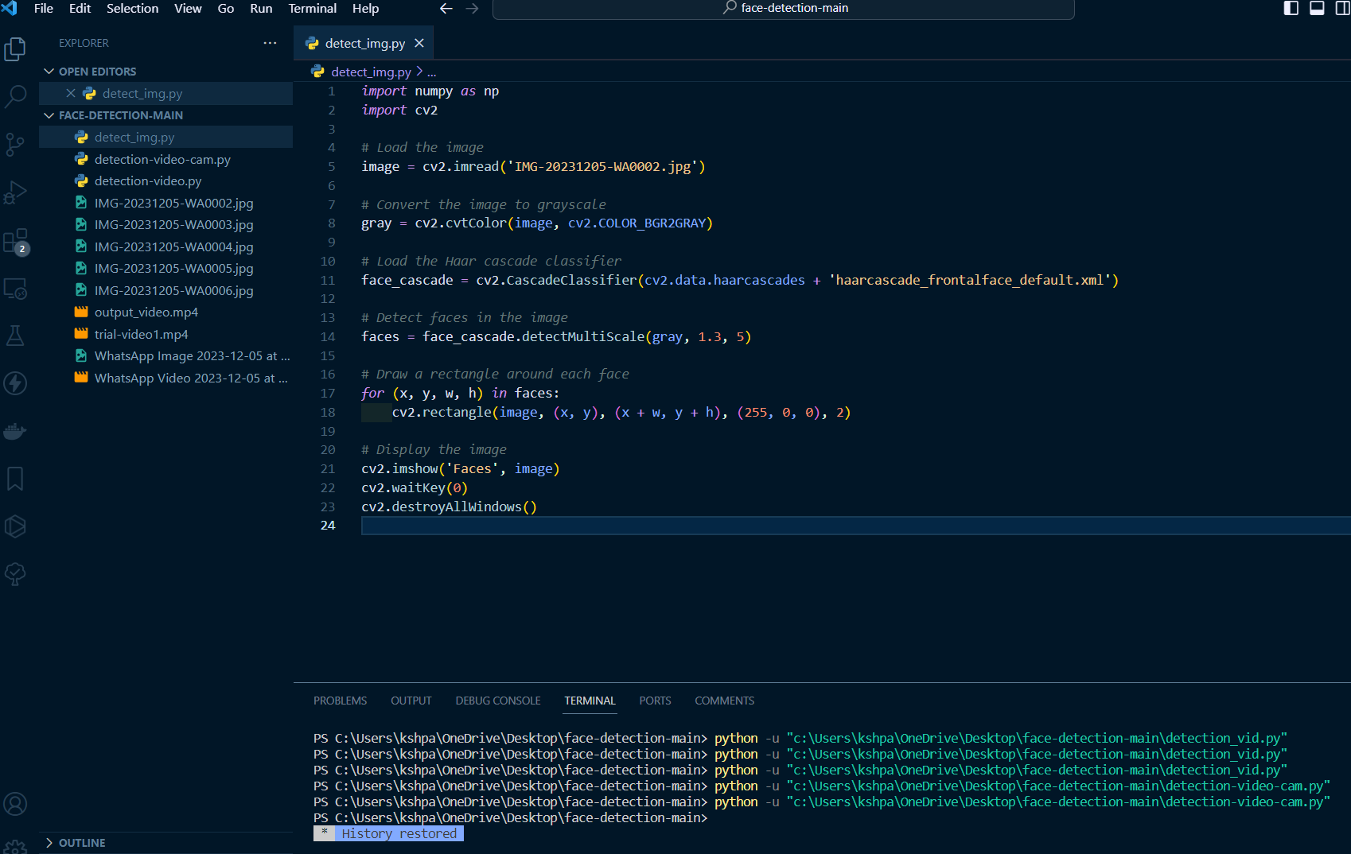

Figure 3.5: Faces.py file

The following script when run gives us the output:

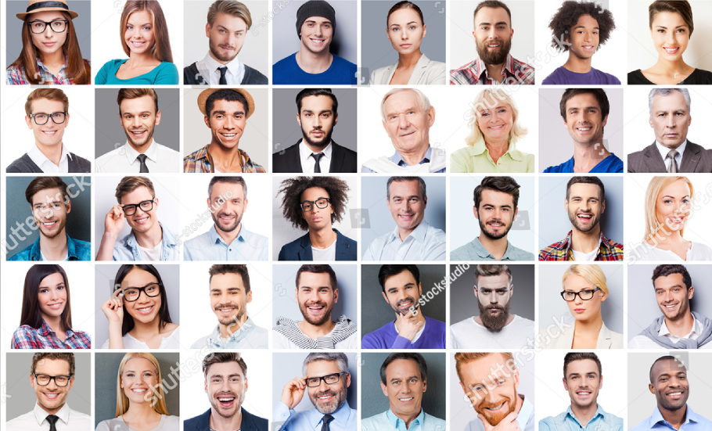

Figure 3.6: Face before Recognition

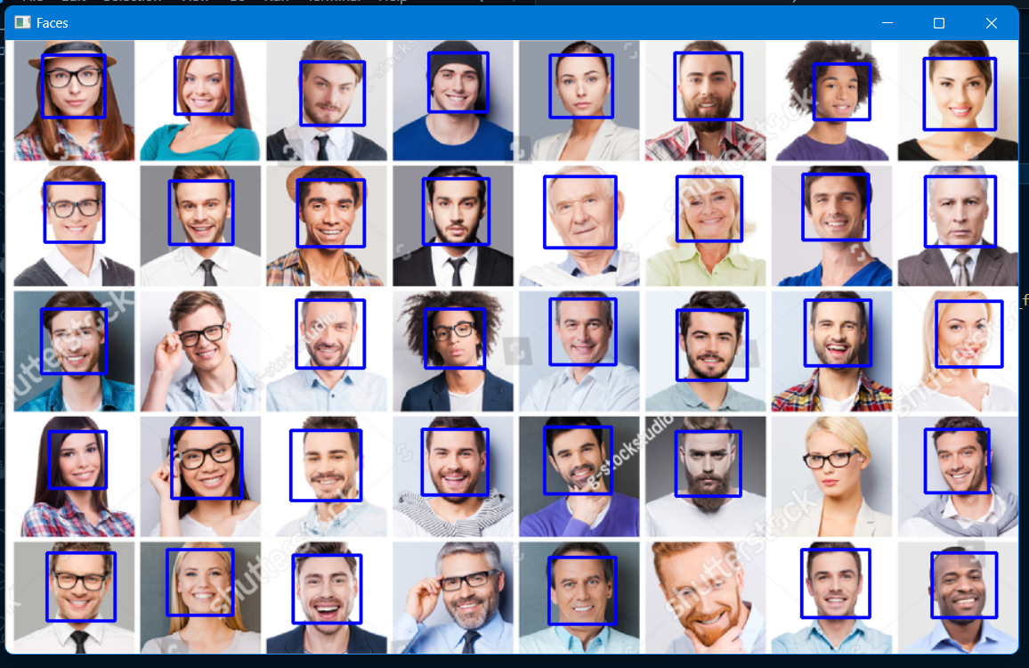

Figure 3.6.1: Detecting a face

### CHAPTER 4: TRAINING AND TESTING

#### TRAINING IN OPENCV

In OpenCV, training refers to providing a recognizer algorithm with training data to learn from. The trainer uses the same algorithm (LBPH) to convert the images cells to histograms and then computes the values of all cells and by concatenating the histograms, feature vectors can be obtained. Images can be classiﬁed by processing with an ID attached. Input images are classiﬁed using the same process and compared with the dataset and distance is obtained. By setting up a threshold, it can be identiﬁed if it is a known or unknown face. Eigenface and Fisher face compute the dominant features of the whole training set while LBPH analyses them individually.

To do so, firstly, a Dataset is created. You can either create your own dataset or start with one of the available face databases.

* Yale Face Database
* AT & T Face Database

The .xml or. yml configuration file is made from the several features extracted from your dataset with the help of the FaceRecognizer Class and stored in the form of feature vectors.

#### TRAINING THE CLASSIFIERS

OpenCV enables the creation of XML ﬁles to store features extracted from datasets using the FaceRecognizer Class. The stored images are imported, converted to Grayscale and saved with IDs in two lists with same indexes. Face Recognizer obj ects are created using FaceRecognizer class. Each recognizer can take in parameters described below.

cv2.face. createEigenFaceRecognizer()

1. Takes in the number of components for the PCA for crating Eigenfaces. OpenCV documentation mentions 80 can provide satisfactory reconstruction capabilities.
2. Takes in the threshold in recognizing faces. If the distance to the likeliest Eigenface is above this threshold, the function will return a -1, that can be used state the face is unrecognizablec

cv2.face. createFisherFaceRecognizer()

1. The ﬁrst argument is the number of components for the LDA for the creation of Fisherfaces. OpenCV mentions it to be kept 0 if uncertain.
2. Similar to Eigenface threshold. -1 if the threshold is passed.

cv2.face. createLBPHFaceRecognizer()

1. The radius from the centre pixel to build the local binary pattern.
2. The Number of sample points to build the pattern. Having a considerable number will slow down the computer.
3. The Number of Cells to be created in X axis.
4. The number of cells to be created in Y axis.
5. A threshold value similar to Eigen face and Fisherface. if the threshold is passed the object will return 1.Recogniser objects are created and images are imported, resized, converted into numpy arrays and stored in a vector. The ID of the image is gathered from splitting the ﬁle name, and stored in another vector.By using FaceRecognizer.train(NumpyImage, ID) all three of the objects are trained. It must be noted that resizing the images were required only for Eigenface and Fisherface, not for LBPH. The conﬁguration model is saved as XML using the function: FaceRecognizer.save(FileName).

cognizer class. The stored images are imported, converted to grayscale and saved with IDs in two listswith same indexes. FaceRecognizer objects are created using face recogniser class.

#### .train() FUNCTION

Trains a FaceRecognizer with given data and associated labels. Parameters:

src The training images, that means the faces you want to learn. The data has to be given as a vector<Mat >. labels The labels corresponding to the images have to be given either as a vector<int> or any other data type.

#### CODE

Given below is the code for creating a .yml file, that is the configuration model that stores features extracted from datasets using the FaceRecognizer Class. It is stored in a folder named ‘recognizer’ under the name ‘training Data.yml’.

DATASET:

This is the code that will be used to create a dataset. It will turn the camera and take number of pictures for few seconds.Given below is the code for face_dataset.py

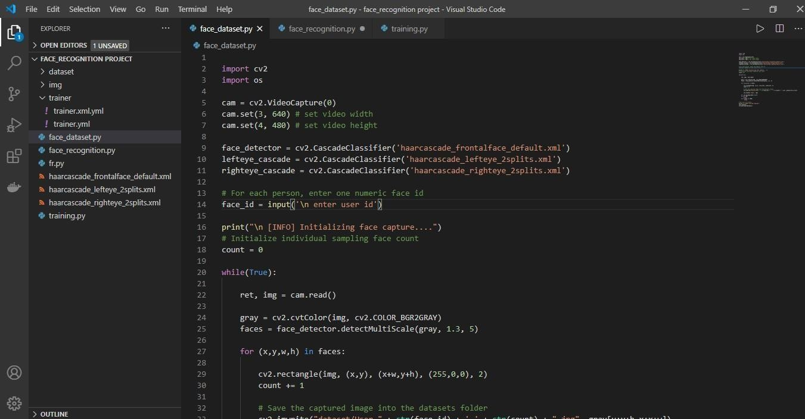

Figure 4.1: Code snippet for the dataset

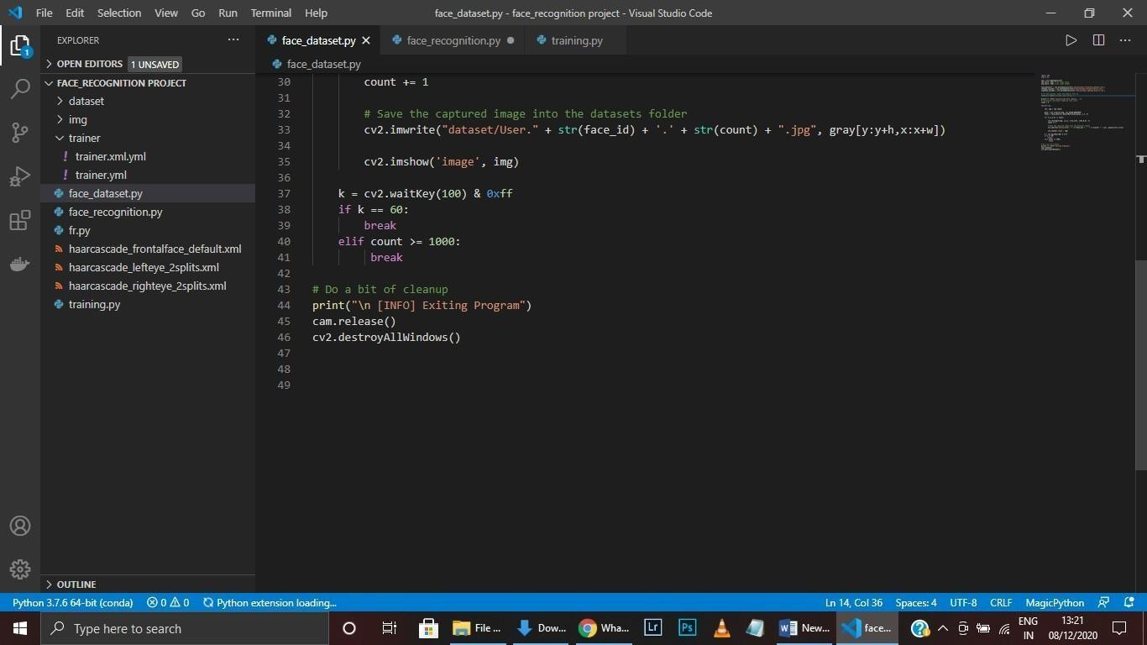

Figure 4.2: Face_dataset.py

#### OUTPUT:

After running the dataset code we will get number of pictures in a folder named dataset. Now these photos will be used to train. The more the pics the greater the accuracy of the trainer.

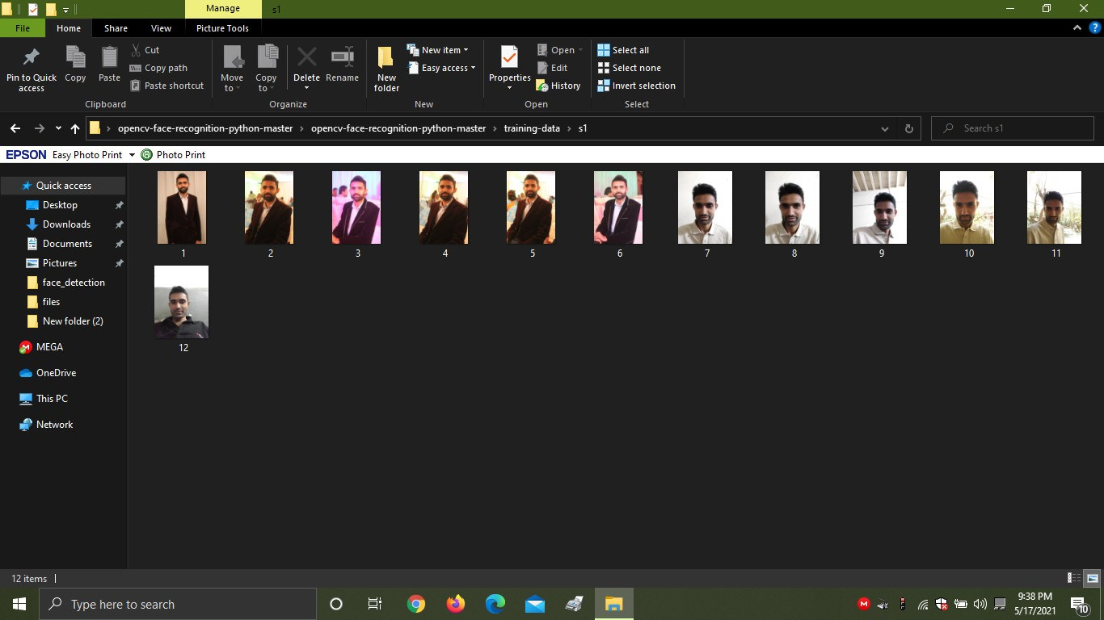

Figure 4.3: example of the script storing the dataset

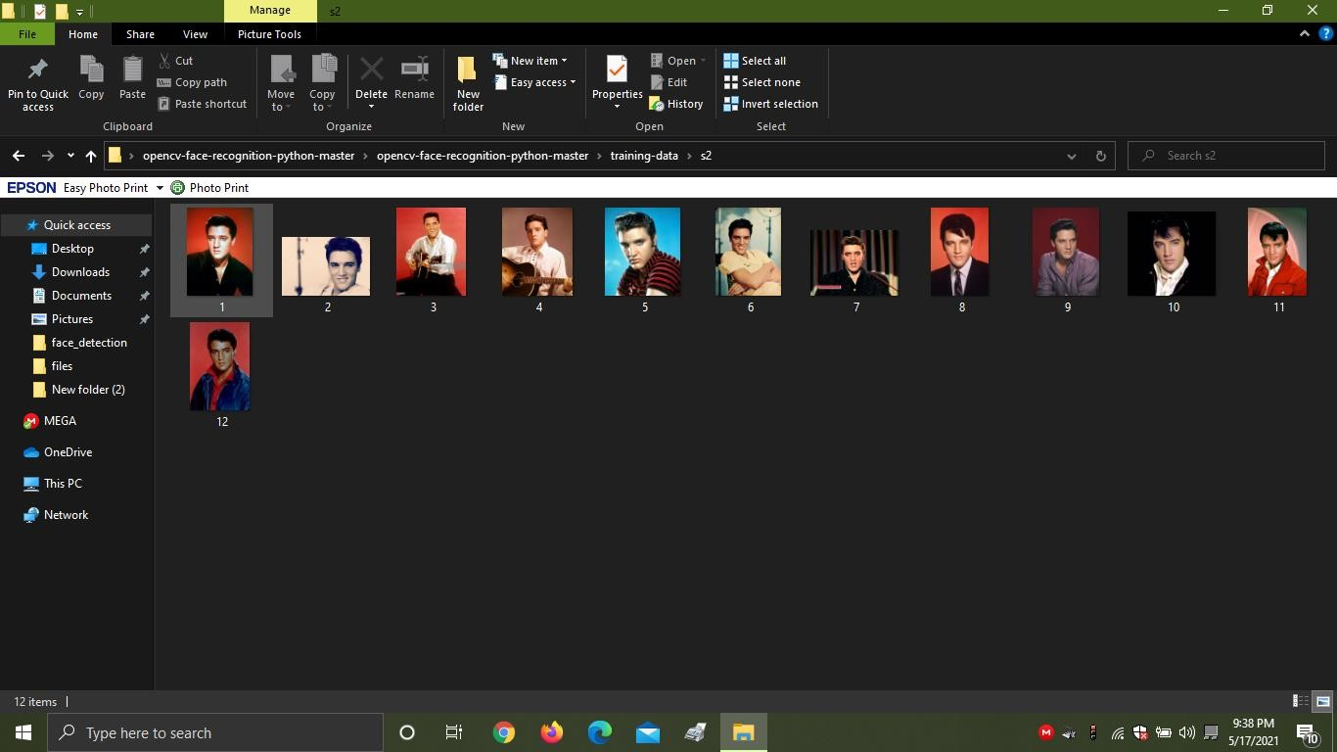

Figure 4.4: Another example

#### TRAINING:

This is the code that is going to be used to train and get the train.yml file

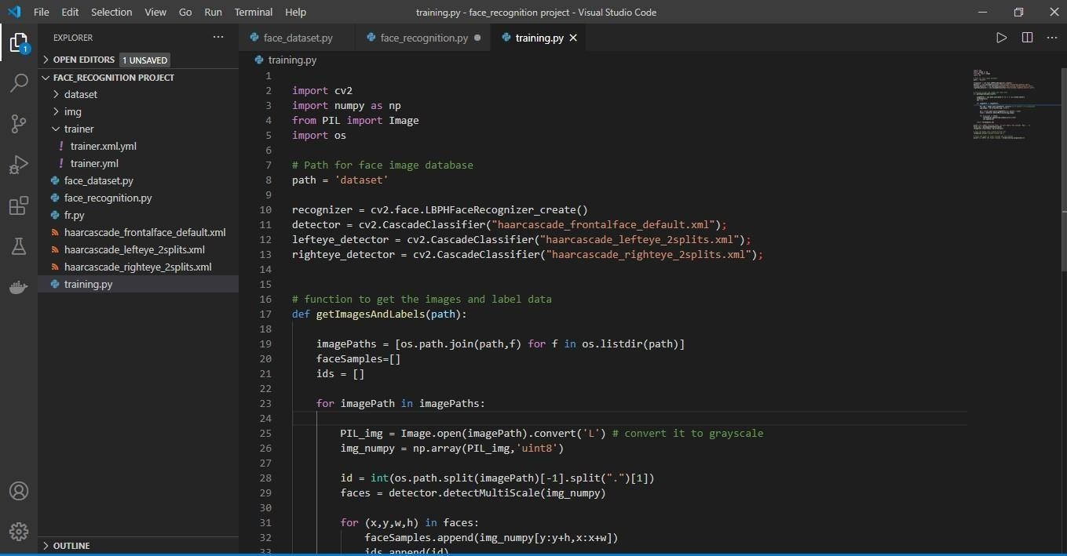

Figure 4.5: Training the dataset

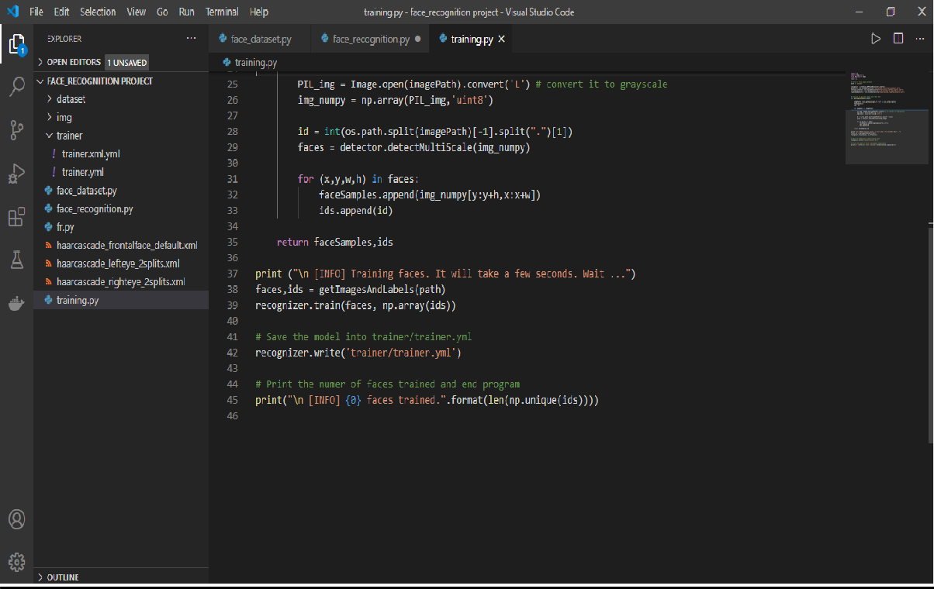

Figure 4.6:Training the dataset after importing

#### OUTPUT:

This is the file that will get created after we run the code train it will take all the images from the dataset that we created previously, using that it will create a file named trainer.yml which will be further used for recognition.

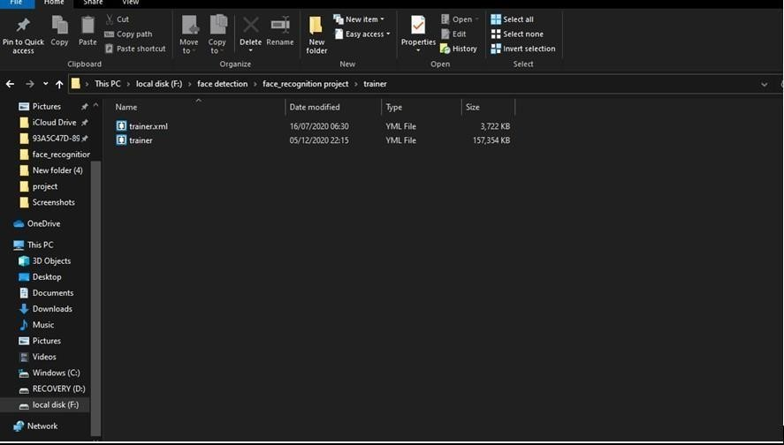

Figure 4.7: The trainer xml file

#### FACERECOGNIZER CLASS

1. Figure 4.8: Flowchart Representation

All face recognition models in OpenCV are derived from the abstract base class Face Recognizer, which provides a unified access to all face recognition algorithms in OpenCV.

It doesn't look like a powerful interface at first sight. But: Every FaceRecognizer is an Al gorithm, so you can easily get/set all model internals (if allowed by the implementation). Algorithm is a relatively new OpenCV concept, which is available since the 2.4 release.

Algorithm provides the following features for all derived classes:

* So called "virtual constructor". That is, each Algorithm derivative is registered at program start and you can get the list of registered algorithms and create instance of a particular algorithm by its name (see Algorithm::create). If you plan to add your own algorithms, it is good practice to add a unique prefix to your algorithms to distinguish them from other algorithms.
* Setting/Retrieving algorithm parameters by name. If you used video capturing function ality from OpenCV highgui module, you are probably familar with cv::cvSetCapturePro perty, ocvcvGetCaptureProperty, VideoCapture::set and VideoCapture::get. Algorithm provides similar method where instead of integer id's you specify the parameter names as text Strings. See Algorithm:set and Algorithm::get for details.
* Reading and writing parameters from/to XML or YAML files. Every Algorithm derivative can store all its parameters and then read them back. There is no need to re- implement it each time.

**Moreover every FaceRecognizer supports the:**

* Training of a FaceRecognizer with FaceRecognizer.train on a given set of images (your face database!).
* Prediction of a given sample image, that means a face. The image is given as a Mat..
* Setting/Getting labels info, that is stored as a string. String labels info is useful for keeping names of the recognized people

#### LBPH RECOGNIZER

The approach that has been used in this project is, LBPH approach which uses the following algorithm to compute the feature vectors of the provided images in the dataset.

Local Binary Patterns (LBP) is a type of visual descriptor used for classification in computer vision. LBP was first described in 1994 and has since been found to be a powerful feature for texture classification. It has further been determined that when LBP is combined with the Histogram of oriented gradients (HOG) descriptor, it improves the detection performance considerably on some datasets.

As LBP is a visual descriptor it can also be used for face recognition tasks, as can be seen in the following Step-by-Step explanation.

In this section, it is shown a step-by-step explanation of the LBPH algorithm: 1.First of all, we need to define the parameters (radius, neighbors, grid x and grid y) using the Parameters structure from the lbph package. Then we need to call the Init function passing the structure with the parameters. If we not set the parameters, it will use the default parameters as explained in the Parameters section.

1. Secondly, we need to train the algorithm. To do that we just need to call the Train function passing a slice of images and a slice of labels by parameter. All images must have the same size. The labels are used as IDs for the images, so if you have more than one image of the same texture/subject, the labels should be the same.
2. The Train function will first check if all images have the same size. If at least one image has not the same size, the Train function will return an error and the algorithm will not be trained.
3. Then, the Train function will apply the basic LBP operation by changing each pixel based on its neighbours using a default radius defined by the user. The basic LBP operation can be seen in the following image (using 8 neighbors and radius equal to 1

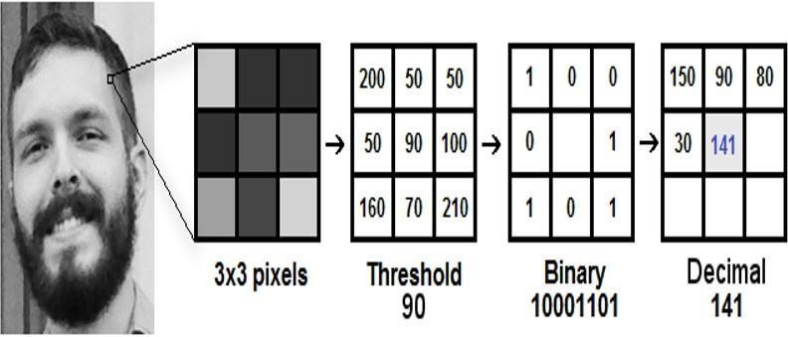

Figure 4.9: referencing and assigning pixel value

1. After applying the LBP operation we extract the histograms of each image based on the number of grids (X and Y) passed by parameter. After extracting the histogram of each region, we concatenate all histograms and create a new one which will be used to represent the image.

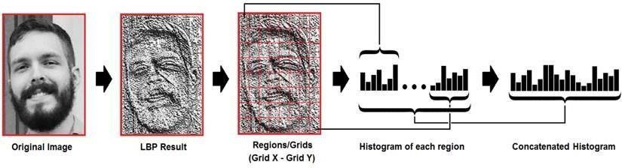

Figure 4.10: LBP result

The images, labels, and histograms are stored in a data structure so we can compare all of it to a new image in the Predict function.

Now, the algorithm is already trained and we can Predict a new image.

To predict a new image we just need to call the Predict function passing the image as parameter. The Predict function

will extract the histogram from the new image, compare it to the histograms stored in the data structure and return the label and distance corresponding to the closest histogram if no error has occurred. **Note**: It uses the Euclidian distance metric as the default metric to compare the histograms. The closer to zero is the distance, the greater is the confidence.

The LBPH package provides the following metrics to compare the histograms:

#### Chi-Square :



Equation 1

#### Euclidean Distance :

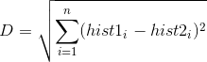

Equation 2

#### Normalized Euclidean Distance :

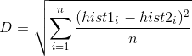

Equation 3

#### Absolute Value :



Equation 4

#### Parameters:

* **Radius**: The radius used for building the Circular Local Binary Pattern. Default value is 1.
* **Neighbours**: The number of sample points to build a Circular Local Binary Pattern from. Keep in mind: the more sample points you include, the higher the computational cost. Default value is 8.
* **GridX**: The number of cells in the horizontal direction. The more cells, the finer the grid, the higher the dimensionality of the resulting feature vector. Default value is 8.
* **GridY**: The number of cells in the vertical direction. The more cells, the finer the grid, the higher the dimensionality of the resulting feature vector. Default value is 8.

#### predict() Function

Predicts a label and associated confidence (e.g. distance) for a given input image. Parameters

|  |  |
| --- | --- |
| src | Sample image to get a prediction from. |
| label | The predicted label for the given image. |
| confidence | Associated confidence (e.g. distance) for the predicted label. |

The suffix const means that prediction does not affect the internal model state, so the method can be safely called from within different threads.

#### Code

Given below is the face recognition script that reads the data from the trainingData.yml file mentioned before and uses the .predict() function to pass a confidence value, recognize the face of the individual and display their names along with their face. The following script uses data that has been trained with images of the students working on this project: Pawan Kumar Sharma

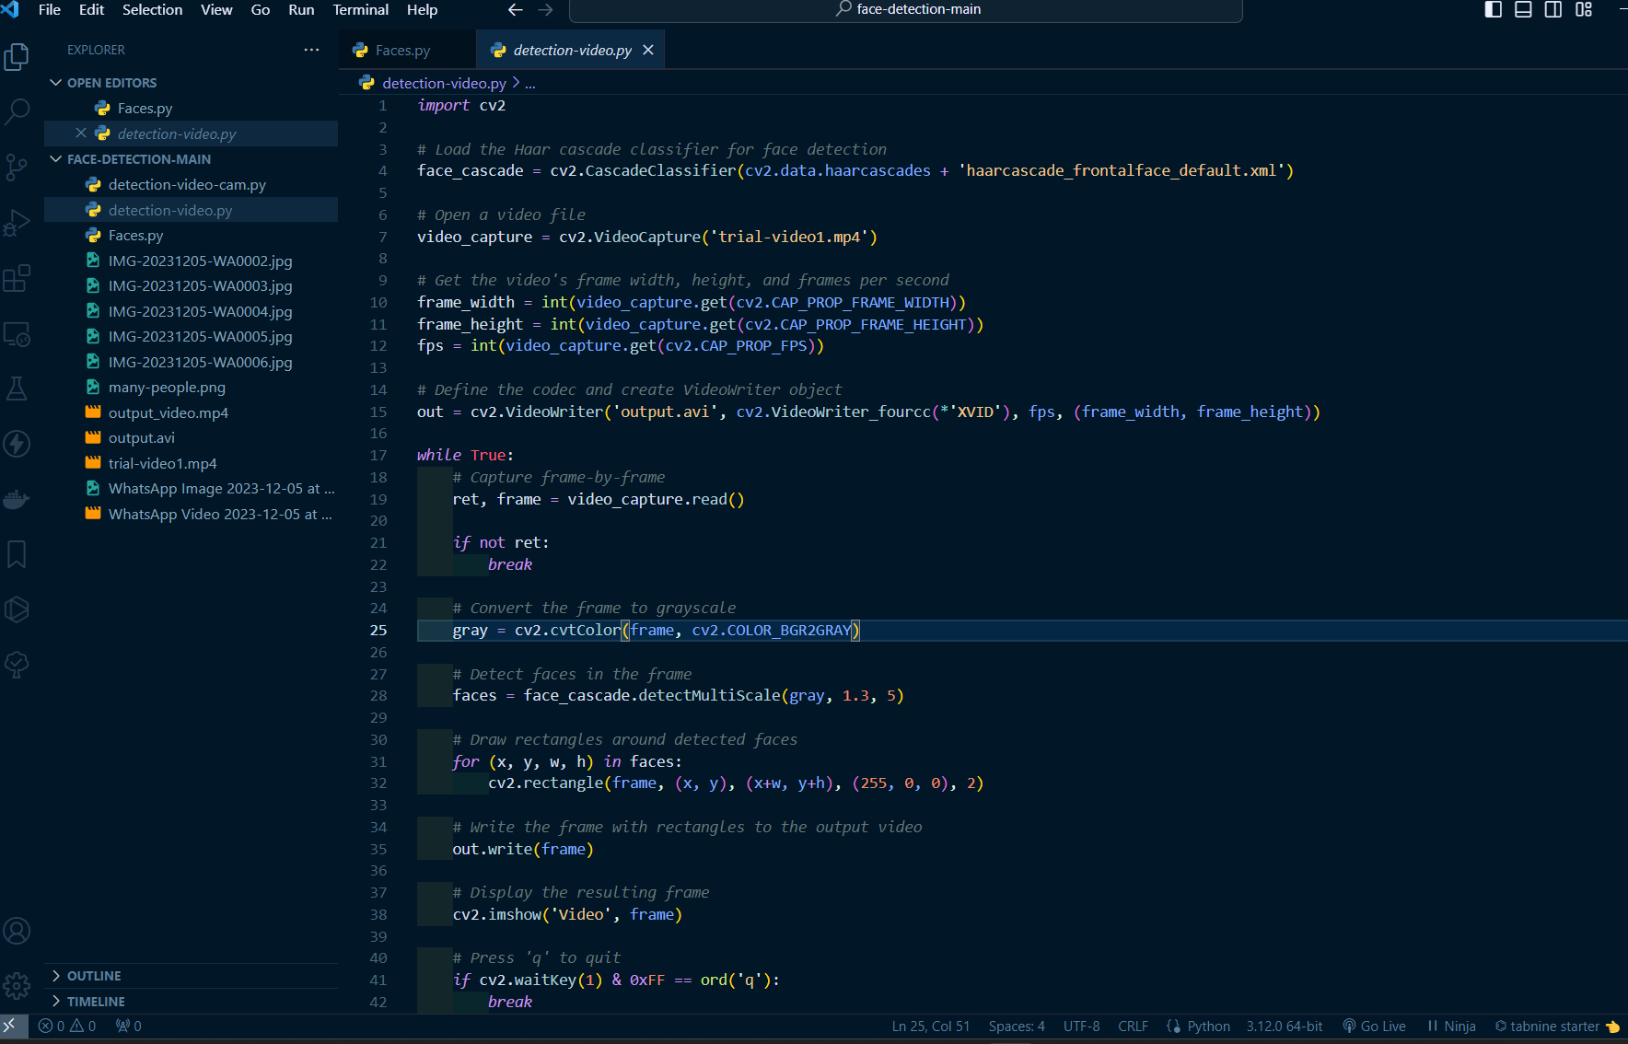

Figure 4.11: Functioning

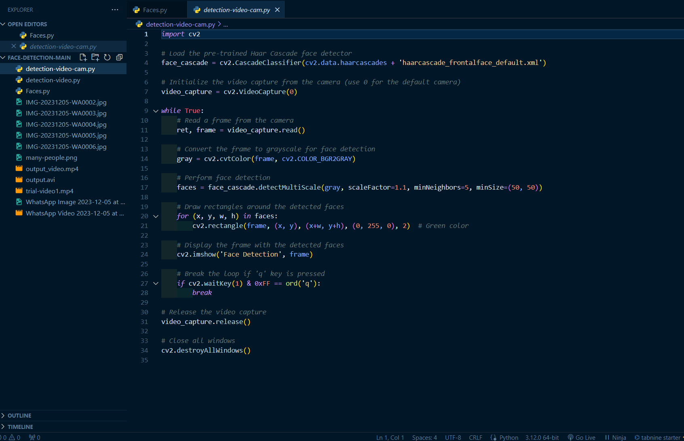

Figure 4.12: Other snippets

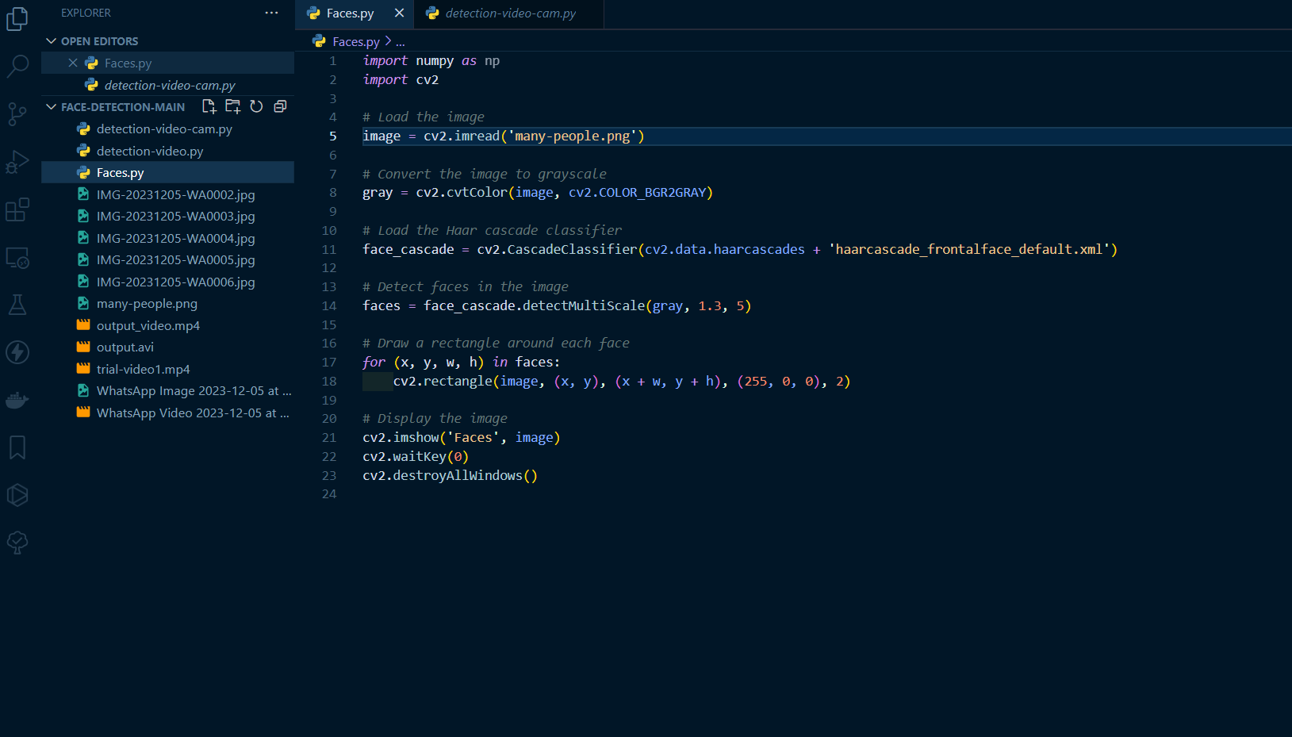

Figure 4.13: Face_recognition.py

#### C:\Users\SHIVAM BHARGAVA\Pictures\Screenshots\Screenshot (7).pngOUTPUT

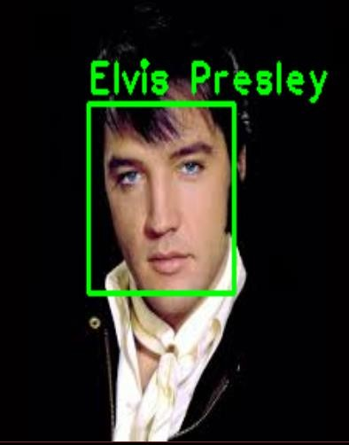Figure 4.14

Figure 4.15

#### APPLICATIONS

* Security: Face Recognition can help in developing security measures, that is unlocking of a safe using facial recognition.
* Attendance Systems: Face Recognition can be used to train a set of users in order to create and implement an automatic attendance system that recognizes the face of the individual and marks their attendance.
* Access: Face Detection can be used to access sensitive information like your bank account and it can also be used to authorize payments.
* Mobile Unlocking: This feature has taken the mobile phone industry by a storm and almost every smart phone manufacturing company has their flagship smartphones being unlocked using face recognition. Apple’s FaceID is an excellent example.
* Law Enforcement: This is a rather interesting way of using face detection and face recognition as it can be used to assess the features of a suspect to see if they are being truthful in their statements or not.
* Healthcare: Face Recognition and Detection can be used in the healthcare sector to assess the illness of a patient by reading their facial features.

### CHAPTER 5: CONCLUSION AND FUTURE SCOPE

#### Future Scope

* Government/ Identity Management: Governments all around the world are using face recognition systems to identify civilians. America has one of the largest face databases in the world, containing data of about 117 million people.
* Emotion & Sentiment Analysis: Face Detection and Recognition have brought us closer to the technology of automated psyche evaluation. As systems now a days can judge the precise emotions frame by frame in order to evaluate the psyche.
* Authentication systems: Various devices like mobile phones or even ATMs work using facial recognition, thus making getting access or verification quicker and hassle free.
* Full Automation: This technology helps us become fully automated as there is very little to zero amount of effort required for verification using facial recognition.
* High Accuracy: Face Detection and Recognition systems these days have developed very high accuracy and can be trained using very small data sets and the false acceptance rates have dropped down significantly.

#### Limitations

* Data Storage: Extensive data storage is required for creating, training and maintaining big face databases which is not always feasible.
* Computational Power: The requirement of computational power also increases with increase in the size of the database. This becomes financially out of bounds for smaller organizations.
* Camera Angle: The relative angle of the target’s face with the camera impacts the recognition rate drastically. These conditions may not always be suitable, therefore creating a major drawback.

### CHAPTER 6: REFERENCES

**Websites:**

* <https://towardsdatascience.com/real-time-face-recognition-an-end-to-end-project-b738bb0f7348>
* <https://www.upgrad.com/blog/face-detection-project-in-python/>
* <https://www.datacamp.com/tutorial/face-detection-python-opencv>
* https://opencv.org/opencv-face-recognition/

**Academic Papers and Research**:

* LFW (Labeled Faces in the Wild) Dataset: A popular dataset for facial recognition research.
* MS-Celeb-1M Dataset: A large-scale face recognition dataset collected from the web.
* FaceNet: A Unified Embedding for Face Recognition and Clustering: Research paper by Google on the FaceNet model.
* DeepFace: Closing the Gap to Human-Level Performance in Face Verification: Research paper by Facebook AI Research on the DeepFace model.

**Blogs and Articles:**

* Towards Data Science: A Medium publication with articles on machine learning, AI, and data science.
* PyImageSearch: A blog by Adrian Rosebrock with tutorials on computer vision and deep learning.
* Analytics Vidhya: Articles, tutorials, and discussions on data science, machine learning, and AI.

**Academic Institutions and Research Centers:**

* Stanford Vision Lab: Research in computer vision, machine learning, and AI.
* MIT Computer Science and Artificial Intelligence Laboratory (CSAIL): Research in various fields of AI and machine learning.

**GitHub Repositories:**

* OpenCV GitHub: Official GitHub repository for OpenCV.
* face_recognition GitHub: GitHub repository for the face_recognition library.
* Dlib GitHub: GitHub repository for Dlib.

**Official Documentation:**

* Python Documentation: Official documentation for the Python programming language.
* NumPy Documentation: Documentation for NumPy, a library for numerical computations in Python.
* SciPy Documentation: Documentation for SciPy, a library for scientific computing in Python.